Connection Tables

ESP32 DevKitC Pinout
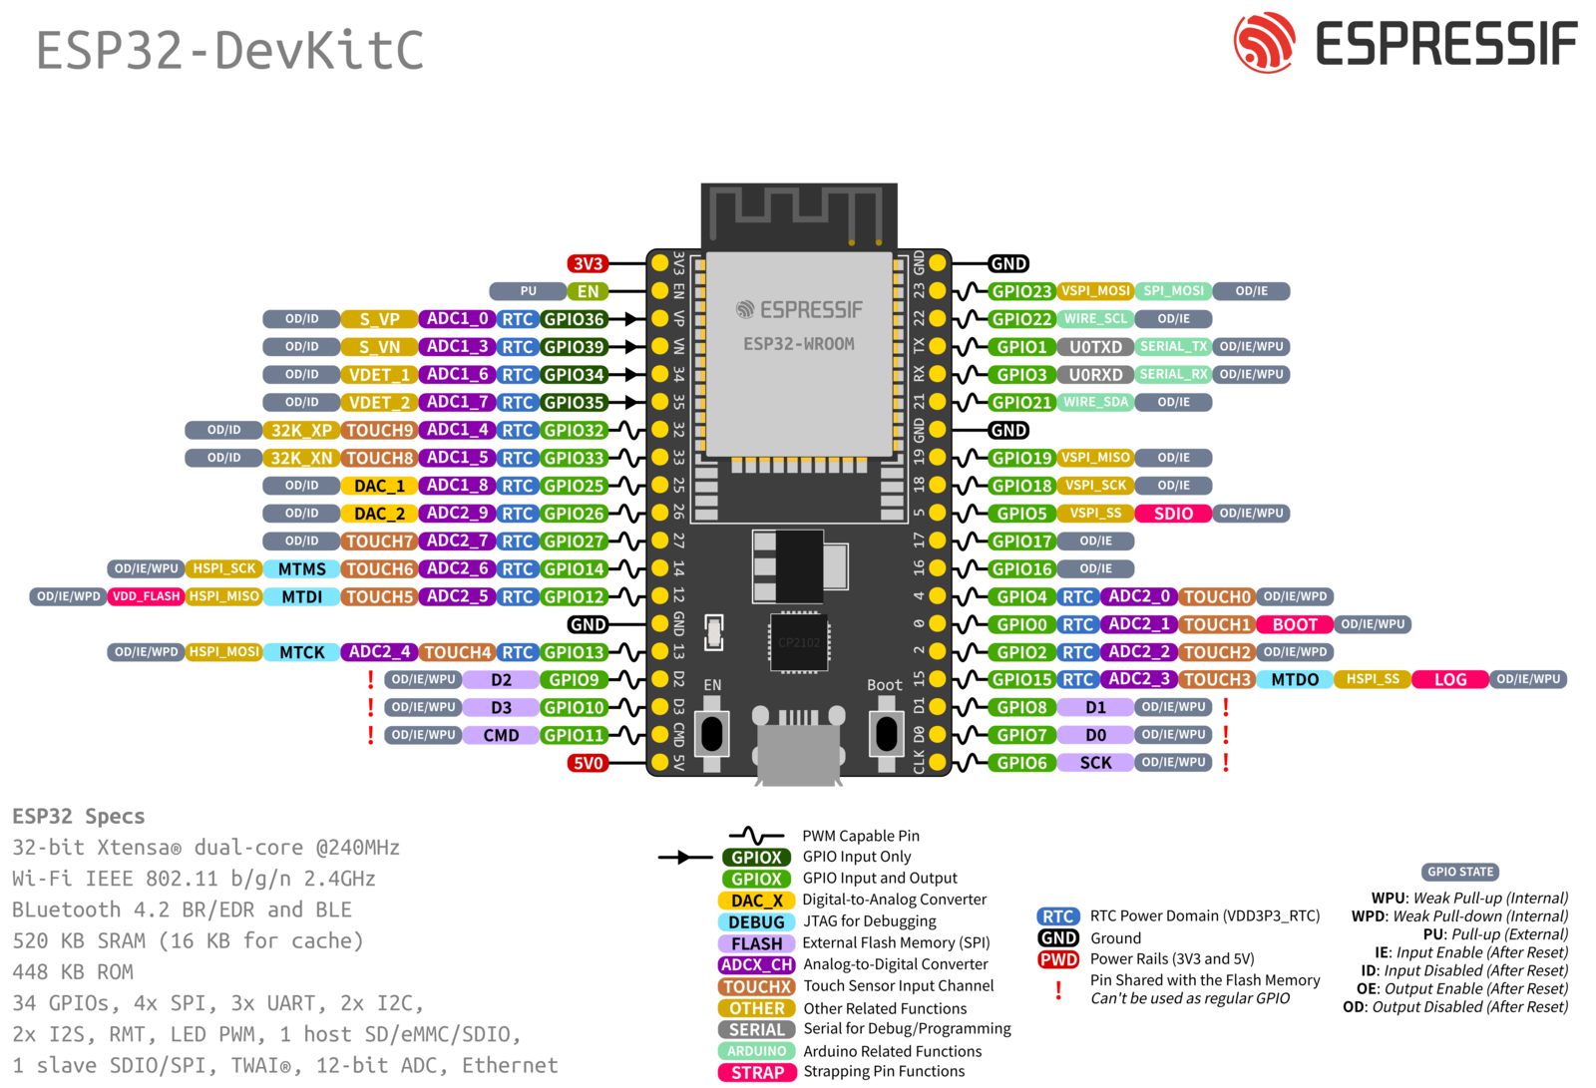

BMS
Name | Pin Name | GPIO | Wire Color
CLK | VSPI_SCK | 18
MOSI | VSPI_MOSI | 23
MISO | VSPI_MISO | 19
CS | VSPI_SS | 05
GND | GND | -

INA226
Name | Pin Name | GPIO | Wire Color
SCL | WIRE_SCL | 22
SDA | WIRE_SDA | 21
GND | GND | -

RTC
Name | Pin Name | GPIO | Wire Color
SCL | WIRE_SCL | 22
SDA | WIRE_SDA | 21
GND | GND | -

Shutoff (pin high, esp32 on. Active low)
Name | Pin Name | GPIO | Wire Color
Signal (D) | GPIO 2 | 02
LED | GPIO 26 | 26
GND | GND | -

Solar_FETs
Name | Pin Name | GPIO | Wire Color
Signal (D) | GPIO 17 | 17
Safety | GPIO 27 | 27
GND | GND | -

Batt_FETs
Name | Pin Name | GPIO | Wire Color
Signal (D) | GPIO 16 | 16
GND | GND | -

Fan
Name | Pin Name | GPIO | Wire Color
Signal (PWM) | GPIO 4 | 04
GND | GND | -

